Muscle Tissue
Muscular tissue is made up of specialized cells called muscle fibres, which are adapted for contraction. Each muscle contains many long, cylindrical muscle fibres arranged in parallel. These fibres contain numerous fine, thread-like structures called myofibrils.
When stimulated, muscle fibres contract and shorten. They later relax and return to their original state. The coordinated contraction and relaxation of muscles produces body movements and helps maintain the position of different parts of the body.
Muscular tissue is classified into three types:
- Skeletal muscle tissue
- Smooth muscle tissue
- Cardiac muscle tissue

1. Skeletal Muscle Tissue
Structure and Arrangement
- Skeletal muscle fibres are striated, giving them a striped appearance.
- The fibres are arranged parallel to one another and grouped into bundles.
- Several bundles are enclosed by a strong connective tissue sheath.
Location
- Skeletal muscles are closely associated with skeletal bones, such as the biceps.
Control
- Skeletal muscles are voluntary muscles, meaning they can be consciously controlled.
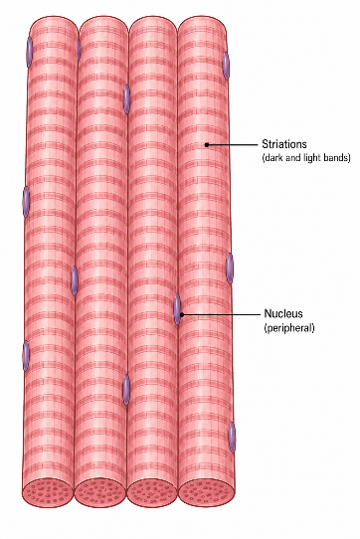

2. Smooth Muscle Tissue
Structure and Arrangement
- Smooth muscle fibres are fusiform, meaning they are narrow at both ends and broader in the middle.
- They do not show striations.
- The cells are connected by cell junctions and arranged in bundles surrounded by connective tissue.
Location
Smooth muscle is present in the walls of internal organs, such as:
- Blood vessels
- Stomach
- Intestine
Control
- Smooth muscles are involuntary, meaning their contractions occur without conscious control.
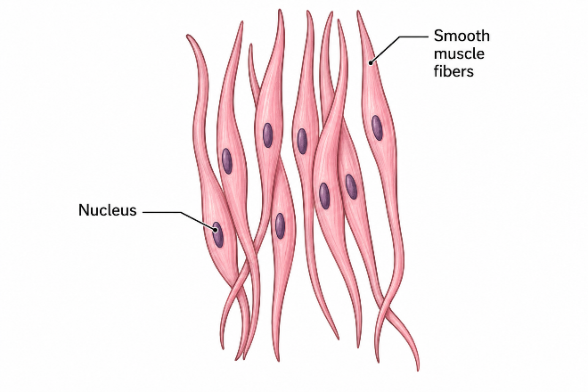

3. Cardiac Muscle Tissue
Structure and Arrangement
- Cardiac muscle is a highly specialized contractile tissue.
- Cardiac muscle cells are connected firmly to one another through specialized cell junctions.
Intercalated Discs
- Specialized junctional regions called intercalated discs occur between cardiac muscle cells.
- These junctions help the cells communicate with one another and allow them to contract in a coordinated manner.
Location
- Cardiac muscle tissue is found only in the heart.
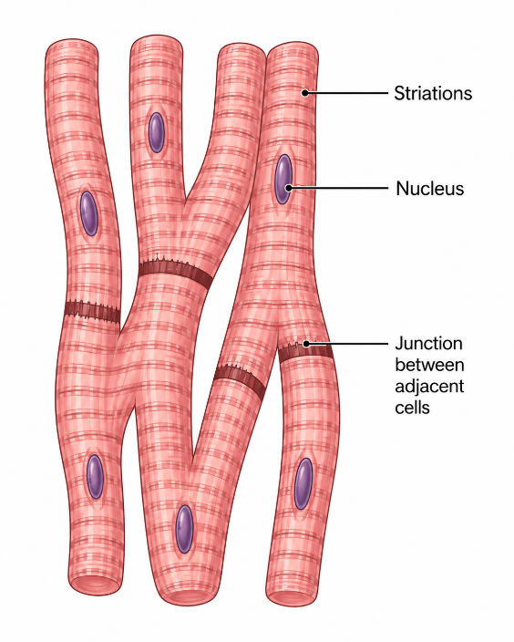
Feature | Skeletal | Smooth | Cardiac
Striations | Present | Absent | Present
Control | Voluntary | Involuntary | Involuntary
Location | Attached to bones | Internal organs | Heart

